Answers Software Systems42(new) Sample 4
A1
A1
Q1(a) Note: Students only need to highlight changes in their answer.
(i)
(i)
class Display extends Thread{
public String name;
public Display(String nm) {name=nm;}
public void run(){
for(int i=0; i<4;i++)
{ System.out.println(name+": "+i);
try{ Thread.sleep(1000);}
catch(Exception e){}}
}
}

public class Q1aSoln
{
public static void main(String[] args)
{
ExecutorService threadExecutor=Executors.newCachedThreadPool();
threadExecutor.execute(new Display("First"));
threadExecutor.execute(new Display("Second"));
}
}

(8 Marks)

Q1b
(i)
Student must explain that the Race condition is occurring and that in
Seq 1 the Producer is working quicker

Seq 2 the Consumer is working quicker

(3 Marks)
(ii)

class NumberStore {
private int contents=0;
private boolean available = false;
public synchronized int get() {
while (available == false) {
try {
wait();
} catch (InterruptedException e) { }
}
available = false;
notify();
return contents;
}
public synchronized void put(int value) {
while (available == true) {
try {
wait(); // give up exclusive access to this object
// put in a queue waiting for access to object
} catch (InterruptedException e) { }
}
contents = value;
available = true;
notify(); // notify that objects data has changed
} // give waiting threads a chance to execute
}

(9 Marks)

Q2(a)(i)
int Hash( int k )
{
int hashvalue = k % N;
return hashvalue;
}

(ii) Collision Resolution
Most Hash Functions are not perfect, this causes table COLLISIONS.
Collision caused by mapping 2 or more keys into the same table location
For example
Node head[]= new Node[20];

Key = 221 221%20 = 1
Key = 2221 221%20 = 1

Both Hash to same location
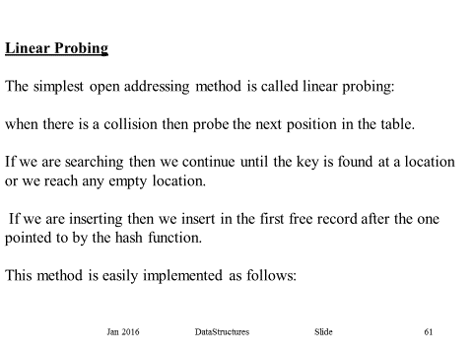

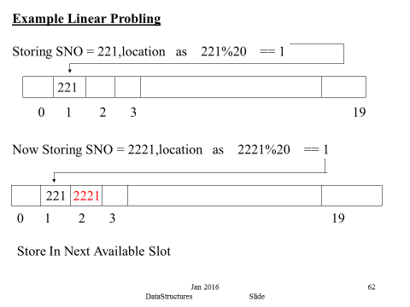
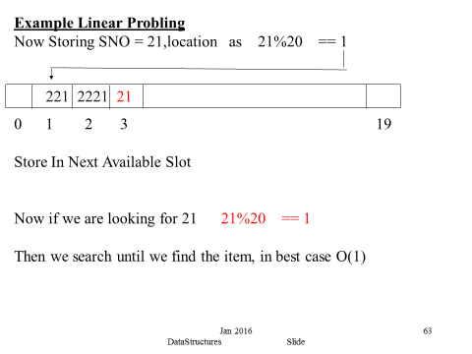

(iii)
Under the assumption of equal likelihood we find the average number of key comparisons done on a successful sequential search.
We simply add the number needed for all the successful searches, and divide by N the number of items in the list.
The result is
1 + 2 + 3 + 4 + 5 +6 .....+ N = S
N N

Now we must get an expression for S in N

Write top line down twice in opposite directions & then add
1 + 2 + 3 + 4 + 5 + 6 .....N-1 + N = S
N + N-1 + N-2+ .........................+2 + 1 = S
N+1 + N+1 + ...... + N+1 + N+1 = 2S

Therefore N(N+1) = 2S

S = N(N+1)
2
=> Average no of key comparisons 1 + 2 + 3 + 4 + 5 +6 .....+ N = S
N N
N(N+1) = (N+1)
2N 2
(6 marks)

Q2(b)
static boolean search(HashSet set,int target){
boolean res=false;
Iterator iter =set.iterator();

while(iter.hasNext())
{ Integer element =(Integer)iter.next();
if (element==target) res=true;
}
return res;

}

static int countEven(HashSet set){
int res=0;
Iterator iter =set.iterator();

while(iter.hasNext())
{ Integer element =(Integer)iter.next();
if (element%2==0) res++;
}
return res;

}
(8 marks)

Q3(a) (8 marks)Q3(a)
class ArrayTest<T extends Comparable<T>>
{
private T [] values;
public ArrayTest(T [] v)
{
values = v;
}
public T first()throws Exception
{
if (values.length == 0) throw new Exception();
return values[0];
}
public T max()throws Exception
{
if (values.length == 0) throw new Exception();
T res = values[0];
for (int i=0;i< values.length;i++)
{
if (res.compareTo(values[i])<0) res = values[i];
}
return res;
}
public void printAll()
{
System.out.println(); System.out.print("[");
for (int i=0;i< values.length;i++)
System.out.print(" " + values[i]);
System.out.println("]");
}
}
public class TestGenericSoln{

public static void main(String[]args){
try{
Double [] a = { 2.3, 6.1, 3.5, 5.2 };
ArrayTest<Double> at = new ArrayTest(a);
double res1 = at.first();
System.out.println("First=" + res1);
double res2 = at.max();
System.out.println("max=" + res2);
at.printAll();
}
catch(Exception e){}
}
} (11 Marks)

Q3.(b)
import java.util.Collections;

public class ArrayList1
{

static int sum(ArrayList list){
if (list.size()==0) return 0;
else{ int first= (Integer)list.get(0);
list.remove(0);
return first + sum(list);
}

}

public static void main( String[] args )
{
ArrayList<Integer> list = new ArrayList();
Collections.addAll(list , 4,5,3,2,3,1,3);
int res1=sum(new ArrayList(list));
System.out.println("Sum of all elements in list="+res1);

}
} (9 Marks)

Q4 public interface Visitor {
public void visit(Visitable v);
}

public interface Visitable {
public void accept(Visitor v);
}

public class Match implements Visitable {
private String team1;
private String team2;
private int score1;
private int score2;

public Match() {
this.team1 = "City";
this.team2 = "United";
}

public void accept(Visitor v) {
v.visit(this);
}
:
}
public class MoreFunctions implements Visitor {

private Match match;
public void visit(Visitable v) {
match = (Match) v;
}
public void restartMatch() {
match.setTeam1Score(0);
match.setTeam2Score(0);
}
public String readScore() {
if (match.readTeam1Score() > match.readTeam2Score()) {
return "United wins";
}
else if (match.readTeam1Score() < match.readTeam2Score()) {
return "City wins";
}
else {
return "Draw";
}
}
}

public class MatchTest {
public static void main(String[] args) {
Match m = new Match();
MoreFunctions mf = new MoreFunctions();
m.accept(mf);
int choice = 1;
while (choice != 6) {
System.out.println();
:
System.out.println("4.Reset");
System.out.println("5.Print End info");
System.out.println("6.Exit");
choice = Console.readInt("Please enter a value-->");
:
else if (choice == 4) {
mf.restartMatch();
}
else if (choice == 5) {
System.out.println(mf.readScore());
}
} // end while
}
}
(20 marks)

